*Florida International University*

*School of Computing and Information Sciences*

Software Engineering Focus

Interactive Paint

User Story ID <3>

**Name:**

Daniel Mederos

**Team Member(s):**

Jim Louro

**Project:**

Interactive Paint

**Product Owner(s)**:

Francisco Ortega

**Mentor(s)**:

**Instructor**: Masoud Sadjadi

**User Story Name:** Create MainMenu

* Description: As a User I would like to create a MainMenu so that the user can select between single and multi touch

Acceptance Criteria

* The MainMenu should present the user with two options: single touch and multitouch

**Use Case** Create an UNDO action in the Canvas

|  |  |  |
| --- | --- | --- |
| #**344** Implement MainMenu | | |
| ***Description*** | When the user first runs the program, it should prompt the user with a MainMenu that has two options for which kind of application they would want to use | |
| ***Actor*** | User of Interactive Paint | |
| ***Precondition*** | Program must be running | |
| ***Flow of Events*** | **User** | **System** |
| **1.** | User runs program | A MainMenu appears with two options |
| **2.** | User clicks on Single touch button | The single touch program will run and a GUI Canvas will appear |
| **3.** | User clicks on multi touch button | The multi touch program will run and a GUI Canvas will appear |

**Use Case Diagram**

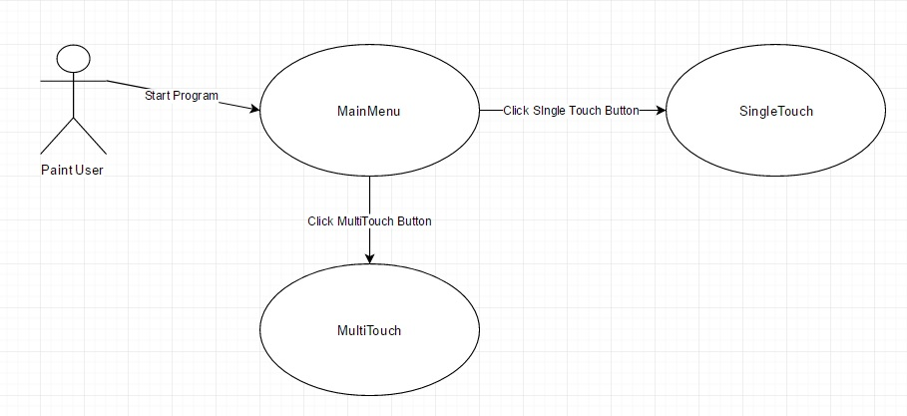

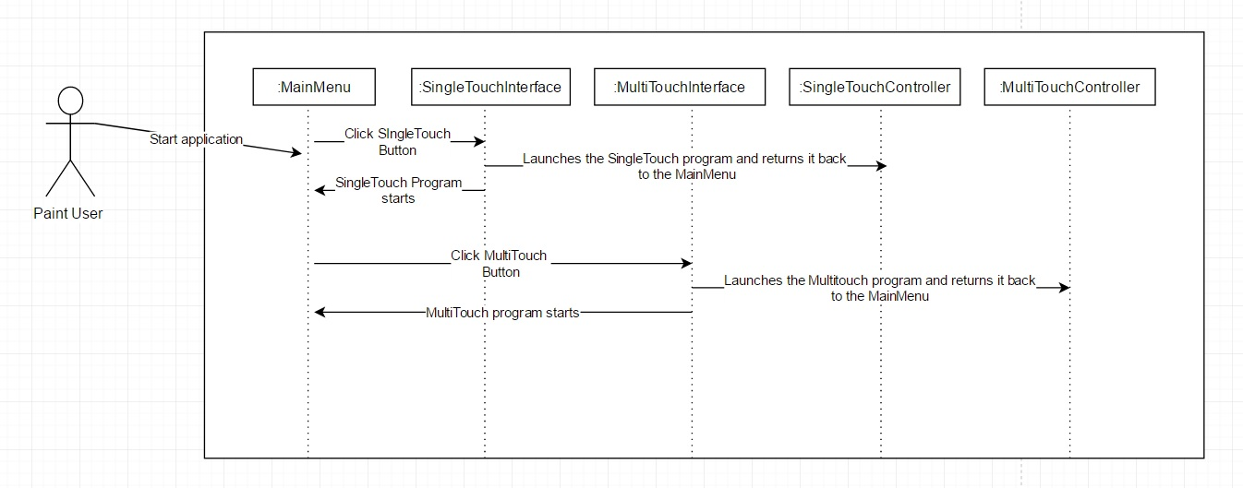**Sequence Diagram**

**Class Diagram**

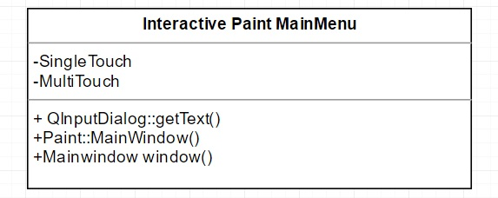

**Integration Test**

**Testing**

**Description:**

* Test the MainMenu and the SingleTouch Button and MultiTouch Button

**Work Log:**

**Unit Test**

**Test Case 1 (Rainy)**

***Purpose:*** to test that the SingleTouch Button launches Single Touch application

* Precondition The user must have QT plugin for visual studio and must run the program
* Input: User clicks on SingleTouch Button
* Expected Result: launches SingleTouch Application
* Actual Result: Does not launch SingleTouch Application
* Status: **FAILED**

**Test Case 2 (Rainy)**

***Purpose:*** to test that the MultiTouch Button launches Multi Touch application

* Precondition The user must have QT plugin for visual studio and must run the program
* Input: User clicks on MultiTouch Button
* Expected Result: launches MultiTouch Application
* Actual Result: Does not launch MultiTouch Application
* Status: **FAILED**

